Change the font of the heading from Serif to Sans Serif

**Steps to reproduce:**

* Open the <https://www.trgroup.co.nz/> page
* Check the font of the heading

**The font is Serif but should be changed to Sans Serif so it better fits with the rest of the text in the page**

Screenshot:



The video should auto play on scroll in its section of the page instead of popping out

**Steps to reproduce:**

* Open the <https://www.trgroup.co.nz/> page
* Scroll to the video section
* Observe the video section – it does not play automatically
* Click on the video to play it
* The video will pop up and play

**The video should auto play when you scroll to it instead of popping out. There could also be a link to that full video if the user wants to see it.**

Screenshot:

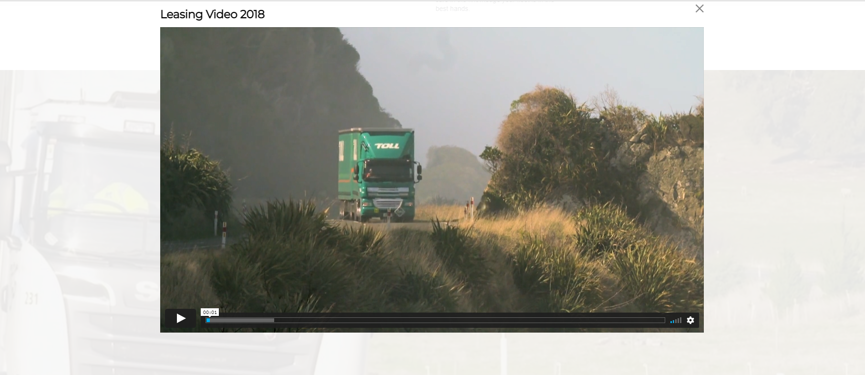

The menu links on hover should have a darker background

**Steps to reproduce:**

* Open the <https://www.trgroup.co.nz/> page
* Hover over menu links on top of the page
* Observe the menu links text and background color

**The background color of the menu links is too bright and the text is hard to read. One option is to make background darker on hover and the second is, for example if they want to stay true to their design language, the background of the hover elements should be black and the text white or yellow.**

Screenshot:

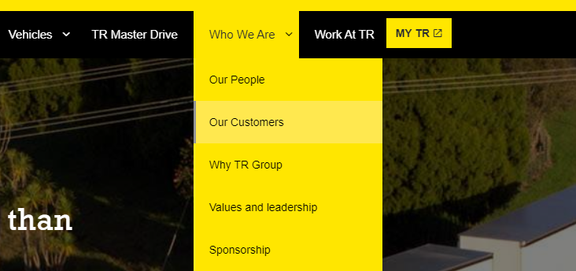

Too much blank space left in the “The TR Group Difference” part of the page and the icons could be centered

**Steps to reproduce:**

* Open the <https://www.trgroup.co.nz/> page.
* Scroll down to “The TR Group Difference” part of the page.
* Observe the icons and the text.

**The first way is explained in the title, the icons should be centered and maybe the icons ant the text rearranged in a way that wouldn’t leave so much blank space on the left.**

**Or it could be done like this: When you hover over the icon you could get the popup text bubble that explains the icon.**

Screenshot:

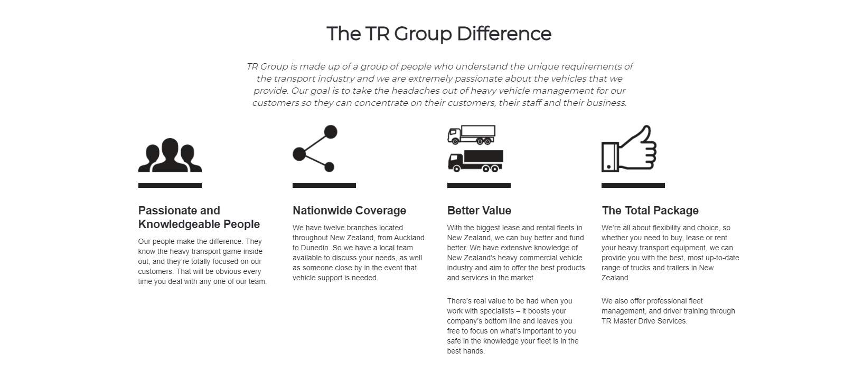

In the “The TR Group Executive Team” part of the page the names should be centered with the above images and phone numbers and the contact links should have stronger color change on hover

**Steps to reproduce:**

* Open the <https://www.trgroup.co.nz/> page
* Scroll down to “The TR Group Executive Team” part of the page.
* Observe the names and alignment with the images.
* Observe phone numbers and emails on hover.

**The texts of the names are slightly to the left of center with corresponding images. Phone numbers and emails should have a stronger color change on hover as the desired hover effect is barely visible.**

Screenshot:

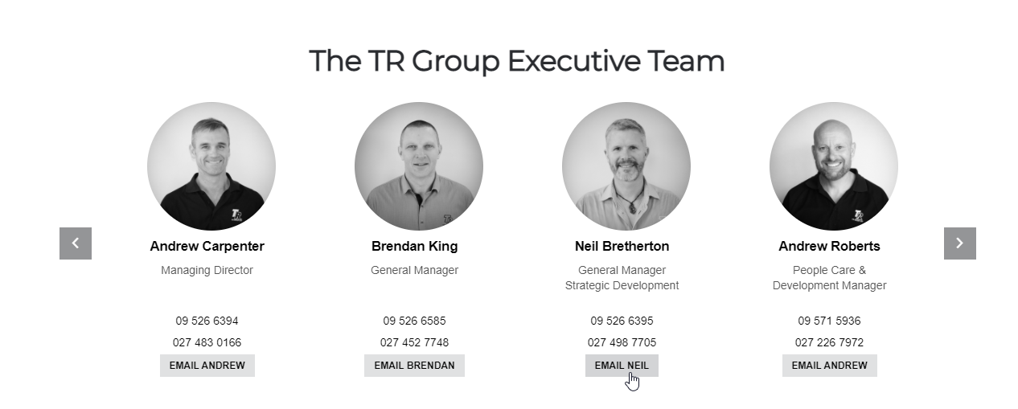



Color difference between hovered and non-hovered “Get Downloads” button is barely visible

**Steps to reproduce:**

* Open the <https://www.trgroup.co.nz/> page
* Scroll down to “Downloads” part of the page
* Observe the Get Downloads button on hover and non-hover

**Color difference is barely visible. Also, following the design language of the site maybe the color of the button should turn white on hover to fit the background a bit better.**

Screenshot:

 

In the Learn More part of the page the lists bullets should not be present and the text should be aligned with the heading

**Steps to reproduce:**

* Open the <https://www.trgroup.co.nz/> page
* Scroll down to “Learn More” part of the page
* Observe the list of links/text

**The bullets should be removed from the list and the links/text should be aligned with the heading above.**

Screenshot:



In the Social pages part of the page the gray rectangle should not appear while hovering over icons

**Steps to reproduce:**

* Open the <https://www.trgroup.co.nz/> page
* Scroll down to “Social pages” part of the page
* Hover over the Facebook or LinkedIn icons
* Observe the gray rectangles appearing on hover

**The gray rectangle should not appear at all on hover, and the icon should change in color or some kind of animation should be implemented. Also the icons should be aligned with the heading since there are only 2 of them.**

Screenshot:



The background color of the scroll to top button could change its color as it enters different sections of the page

**Steps to reproduce:**

* Open the <https://www.trgroup.co.nz/> page
* Scroll down to the yellow parts of the page so the scroll to top button is barely visible
* Observe the button

**The background color of the button should change as it is barely visible when the background of the site is same yellow color.**

Screenshot:

